**CHAPTER-1 Class Room Objective**

**SERIES COMPLETION**

**Directions: Select the related figure from the answer figure.**

**Q1**. Question figure

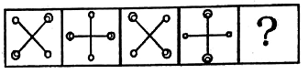

Answer figure

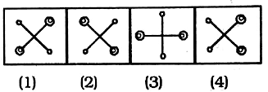

**Q2.** Question figure

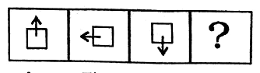

**Answer figure**

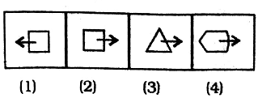

**Q3.**Question figure

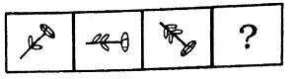

**Answer figure**

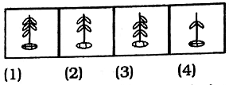

**Q4**. Question figure

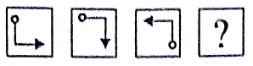

Answer figure

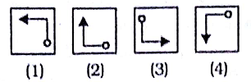

**Q5. Question figure**

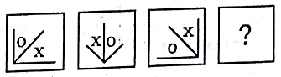

**Answer figure**

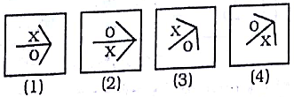

**Q6. Question figure**

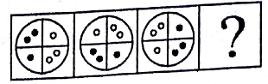

**Answer figure**

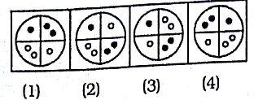

**Q7. Question figure**

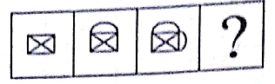

**Answer figure**

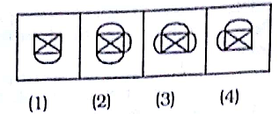

**Q8. Question figure**

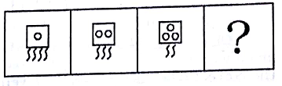

**Answer figure**

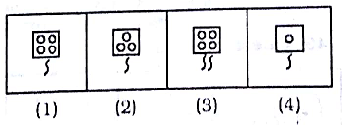

**Q9.** Question figure

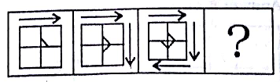

Answer figure

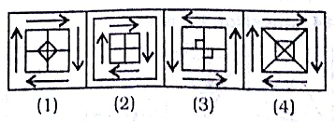

**Q10. Question figure**

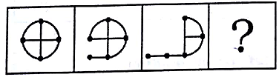

**Answer figure**

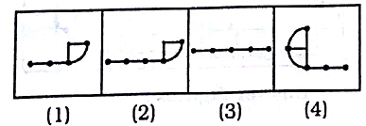

**Q11.** Question figure

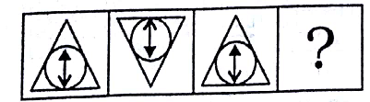

Answer figure

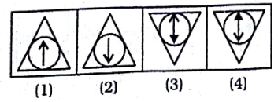

**Q12**. Question figure

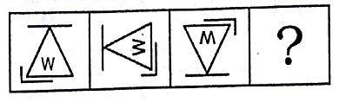

Answer figure

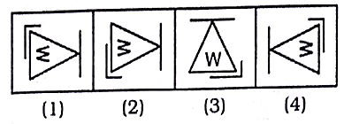

**Q13**. Question figure

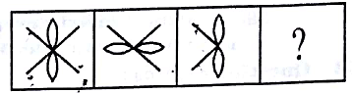

Answer figure

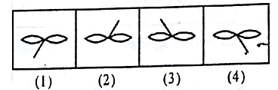

**Q14**. Question figure

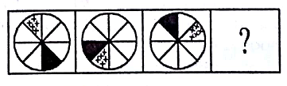

Answer figure

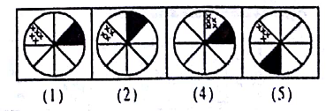

**Q15. Question figure**

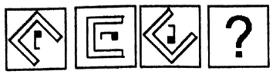

**Answer figure**

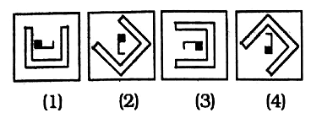

**Q16. Question figure**

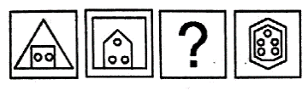

**Answer figure**

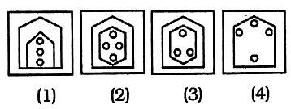

**Q17. Question figure**

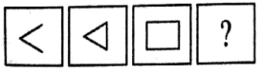

Answer figure

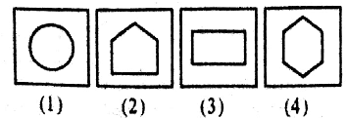

**Q18. Question figure**

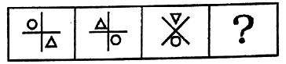

Answer figure

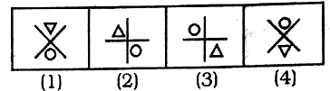

**Q19. Question figure**

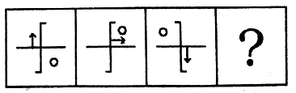

**Answer figure**

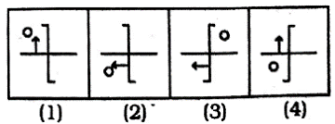

**Q20.** Question figure

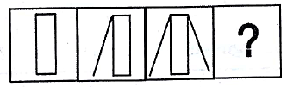

Answer figure

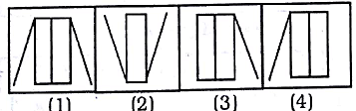

**Q21.** Question figure

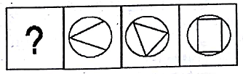

Answer figure

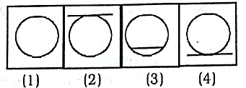

**Q22. Question figure**

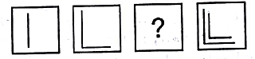

**Answer figure**

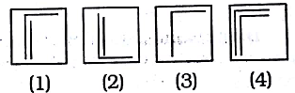

**Q23. Question figure**

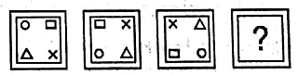

**Answer figure**

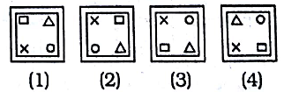

**Q24.** Question figure

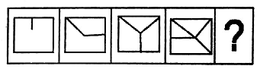

Answer figure

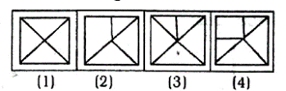

**Q25. Question figure**

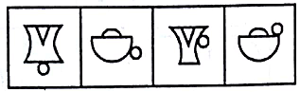

**Answer figure**



